Steps to view chart

Extract details to a folder

On the browser enter path to folder with index.php at the end

Get data via post man to analyze the json and create ajax request

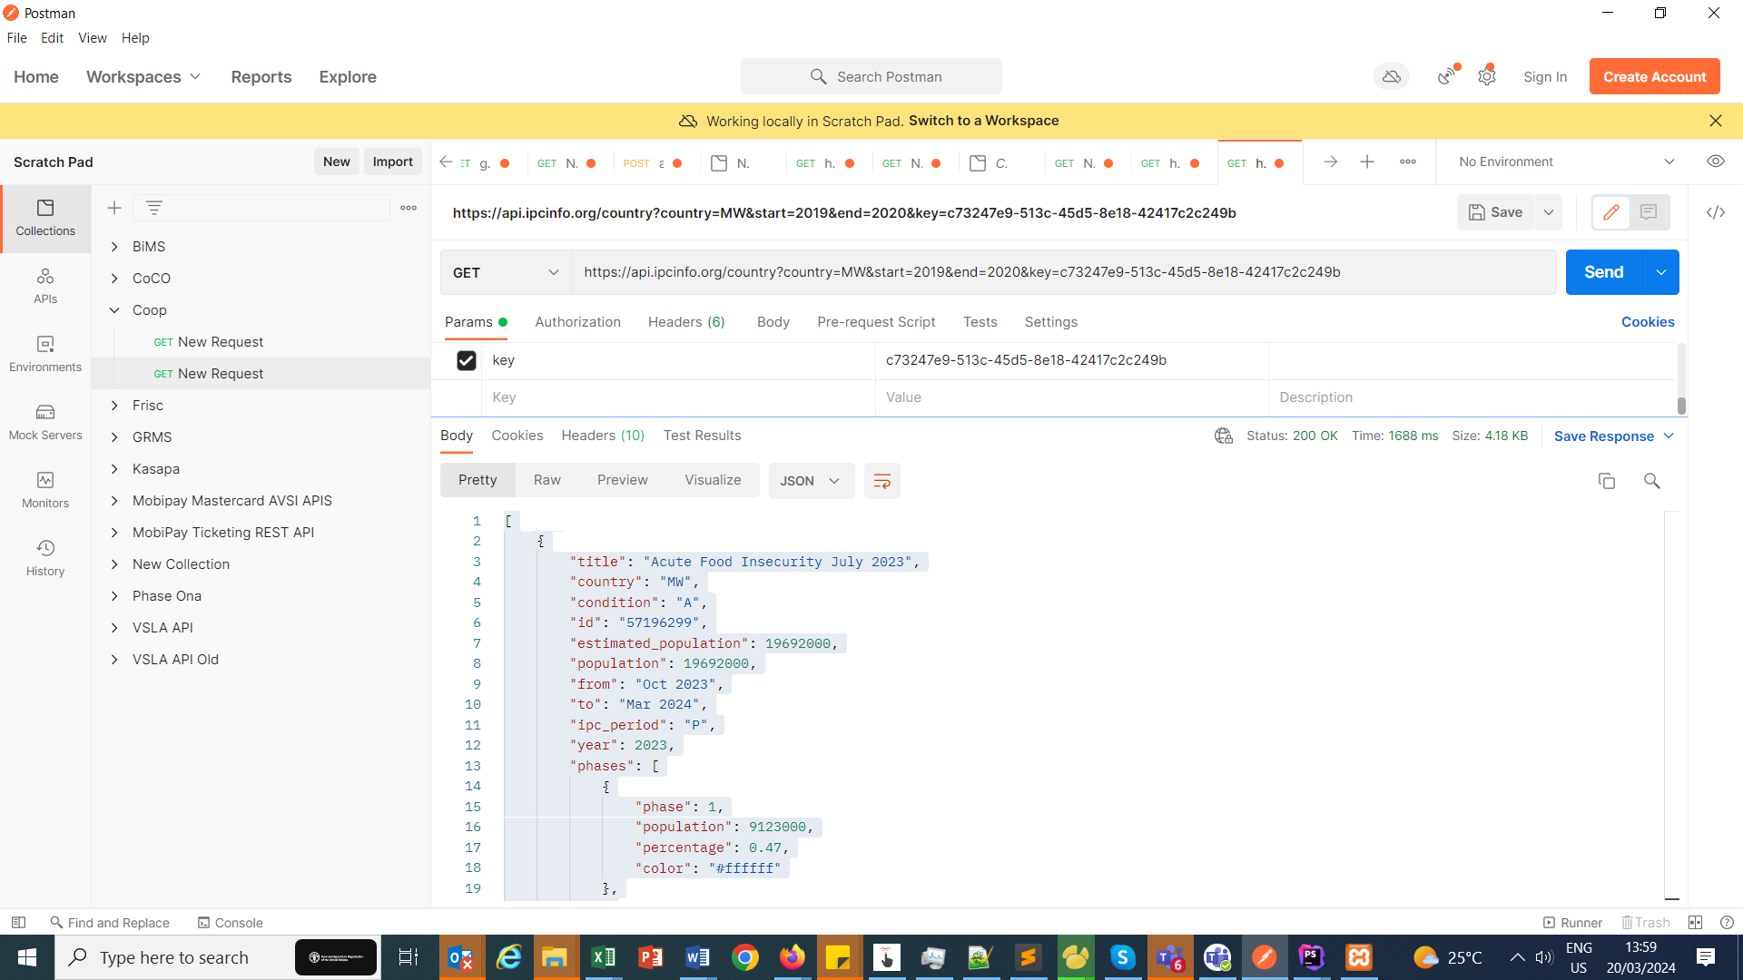

Recreate url

//Define all variables  
const ***api_url*** = 'https://api.ipcinfo.org/country?';  
const ***country*** = "MW";  
const ***country_name*** = "Malawi";  
const ***start*** = "2019";  
const ***end*** = "2020";  
const ***key*** = "c73247e9-513c-45d5-8e18-42417c2c249b";  
var ***url*** = ***api_url*** + "country=" + encodeURIComponent(***country***) + "&start=" + encodeURIComponent(***start***) + "&end=" + encodeURIComponent(***end***) + "&key=" + encodeURIComponent(***key***);